Cobi Gottschalk

**Post-Excavation Specialist Report**

**Title:**

So You Think Your Jeans Are Clean? The Preservation of Pollen from Washed Clothing

1. **Layman’s Summary:**

The aims of this research is to determine whether soil containing pollen, that has been transferred onto clothing, can still be found and analyzed after being washed. Soil was gathered from Sefton Park located in Liverpool United Kingdom and was then examined to determine whether the sample contained any sorts of organic material such as pollen. Once pollen was verified to be in the sample, the soil was applied to nine squares of denim jean material. All of these fabrics were then ran through a series of wash cycles and analyzed for traces of pollen. Results showed that even after three standard wash cycles, pollen could still be found on the fabric material. This research further adds to our understanding of the transfer and retention of pollen to and from clothing, which may be beneficial for law enforcement and archaeologists to know.

1. **Introduction:**

In forensic anthropology, trace evidence of soil can help investigators to better understand the overall background of a crime due to its highly individualistic characteristics. The particles contained within soil deposits have a high probability of transfer and retention which makes the objects it adheres to, such as articles of clothing, potential evidence in criminal investigations (Young et al., 2015). It can establish whether a suspect or victim was possibly at a particular site when a crime occurred. Therefore, by nature, it can provide useful circumstantial evidence in various casework scenarios (Scott et al., 2014). However, the current techniques used in forensic soil examination are sophisticated and analytical (Murray et al., 2015).

The examination of soil in forensics can be complex due to the diverse and heterogeneous characteristics of natural and anthropogenic soils (Murray et al., 2015). Natural soils are very diverse, each containing their own morphology, organic matter composition, and mineralogy. In the United States alone, there are over fifty-thousand different varieties of soil. Anthropogenic soils are usually found in urban and suburban areas and have undergone manipulation over time due to human activity (Fitzpatrick, 2013). This can range anywhere from manufactured bricks and paint flecks to explosive residues (Fitzpatrick, 2015).

The organic matter that can be found in natural soils such as pollen can be used as a geolocation tool because every region on Earth has a specific plant population that produces specific pollens or spores (Warny, 2013). Just as there is a vast variety of soil in the United States, there are also thousands of microhabitats, each consisting of their own unique blend of flora (Bryant and Jones, 2006). Therefore, these pollen prints that plants produce can be useful in tracking the provenance of items obtained from a crime scene such as drugs, food, and clothing (Warny, 2013). This branch of study known as forensic palynology, is a forensic tool that has been used sparingly since the 1950’s even though it has the potential to disprove alibis, narrow down suspects, determine the travel history of an object and so forth (Mildenhall et al., 2006). This is due to a number of reasons such as scarce funding for the discipline, a lack of universities or training facilities that teach forensic pollen analysis, which then in turn produces few specialists who are inexperienced in this field (Bryant and Jones, 2006).

However, for those who are able to go on and specialize in this field of study, they become very useful assets to law enforcement. These palynologists follow a principle known as the Locard’s Exchange Principle which states that any two objects which come in contact with one another will experience a transfer of material (Mildenhall et al., 2006). In forensic cases, which have secured convictions through palynological evidence, the adhesion of pollen on fabric material such as articles of clothing is critical. As previously mentioned, soil contains organic material such as pollen which can then be indirectly transferred to clothing. Furthermore, there can be a loss of pollen from clothing through everyday activities. This can range from any activity in which one could possibly shake or rub it off during wear (Webb et al., 2018). This poses the question of as to whether pollen can still be recovered from clothing that has undergone multiple wash cycles, and if so, would it pose a potential risk of contamination to archaeological sites if archaeologists were to wear washed denim jeans to different excavations?

1. **Methods:**

Soil was collected from Sefton Park and brought back to the lab for analysis. The soil was placed inside of a beaker containing water and sodium hydroxide, which was then heated onto a hot plate until boiling. Once the sample was boiling, it then underwent a process of sieving which included using a one hundred micron mesh to remove large particles and a six micron mesh to further remove any leftover fine sand or silt (Hunt, 1985). The leftover material was stained, pippeted, and placed onto a slide for microscopic examination. Once pollen was determined to be present in the sample, a controlled mixture of two cups of soil and 350 ml of water were hand rubbed into nine five and half by six pieces of denim jean material. The fabric material was then placed into an AEG Electrolux LAVAMAT_ TURBO washing machine with one ARIEL detergent capsule.

Each cycle was ran for sixty-two minutes on a standard 40 degree Celsius wash. After the first cycle was completed, three of the fabric pieces were removed and the remaining six were washed again with another ARIEL detergent capsule using the same washer settings. Once the second wash was completed, another three fabric pieces were removed and the same process was repeated for the last three fabric pieces for the final wash cycle. All of the fabric material was packaged into their own respective plastic bags to avoid contamination and then brought to the lab for analysis.

**Figure 1. AEG washing machine.** **Figure 2. Samples heated using hot plate.**

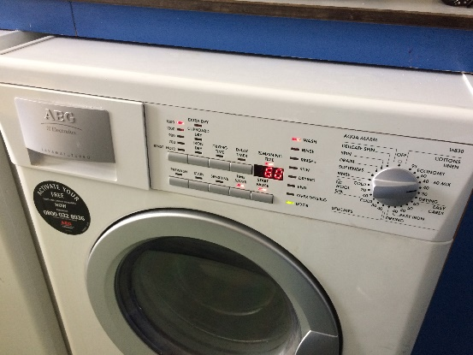 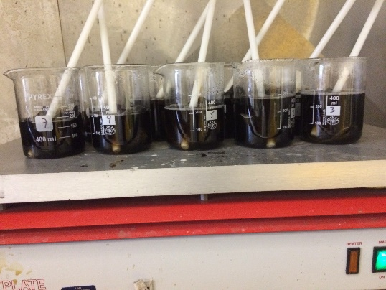

The nine fabric materials were categorized into sample numbers and each were cut into four squares. Samples one through three underwent one wash. Samples four through six went through two wash cycles and samples seven through nine underwent three washes. These were all placed into beakers containing sodium hydroxide and 250ml of water, which was then heated until boiling with a hot plate and stirred with separate stirring rods. The samples each went through a process similar to the one used to check for pollen in the original soil sample collected from Sefton Park. The main difference being that the water from the fabric material in the beakers were wrung through the one hundred micron sieve to ensure for maximum results. All of the sample material recovered was stained and made into slides for microscopic analysis.

**Figure 3. Sample material sieved using 100 micron and 6 micron mesh.**

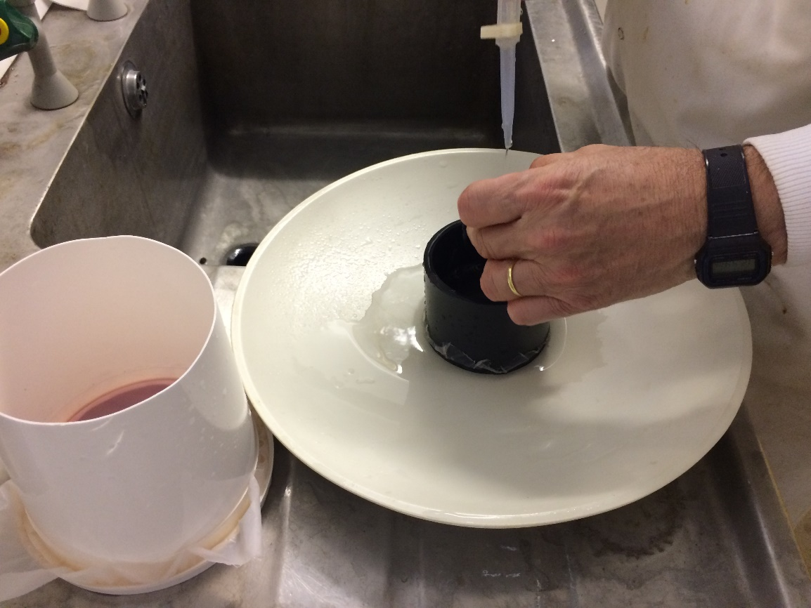

**Figure 4. Sample material recovered stained.**

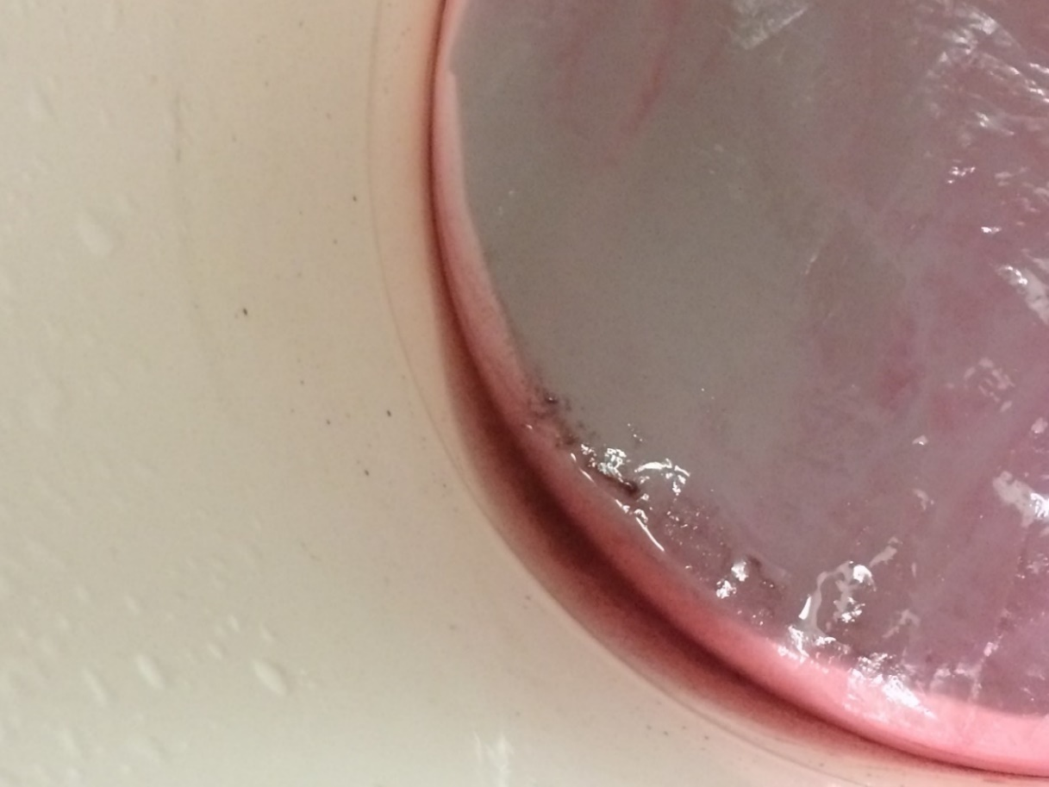

|  |  |  |  |  |  |
| --- | --- | --- | --- | --- | --- |
| **Pollen Grains Recovered from Wash Cycles** | | | | | |
| Sample # | # of Pollen Grains Counted | Total # of Pollen Grains Counted | # of Transverses | Total # of Transverses | # of Wash Cycles |
| Sample # 1 | 26 | 70 | 3 | 9 | 1 |
| Sample # 2 | 22 | 3 |
| Sample # 3 | 22 | 3 |
| Sample # 4 | 4 | 7 | 3 | 9 | 2 |
| Sample # 5 | 2 | 3 |
| Sample # 6 | 1 | 3 |
| Sample # 7 | 4 | 6 | 3 | 9 | 3 |
| Sample # 8 | 1 | 3 |
| Sample # 9 | 1 | 3 |
|  | | | | | |

1. **Results:**

**Table 1. Chart showing the number of wash cycles and number of pollen recovered from the different samples.**

Results from samples one through three, which had undergone one wash cycle, showed substantial amounts of pollen grain. There was a presence of various plant fibers, fungi spores, ivy grain, oak pollen, etc. With three transverses across the twenty-two millimeter coverslip, there was a count of twenty-six pollen grains for sample one. Sample two and sample three showed similar results with twenty-two pollen grains being counted for both samples. Table 1 shows the total number of pollen grains counted for all of the samples as well as the accumulated total number for groups of the same wash cycle.

**Figure 5. Pollen recovered from Sample 1.** **Figure 6. Pollen recovered from Sample 3.**

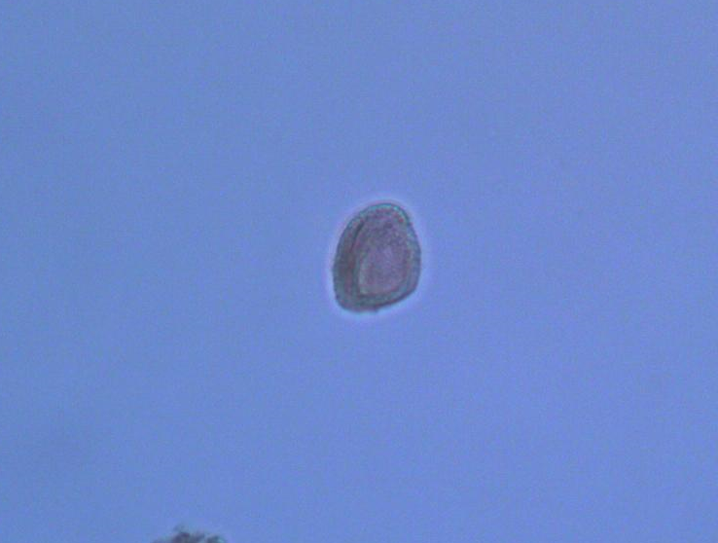 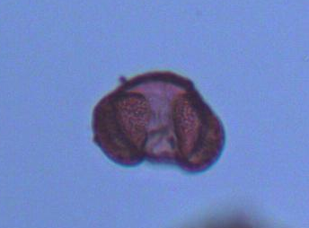

Samples four through six showed that there was a decline in the amount of pollen present after the jeans had gone through two wash cycles. There were four pollen grains counted for sample four, two pollen grains for sample five, and one pollen grain for sample six.

**Figure 7. Pollen recovered from Sample 5.**

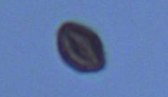

Samples seven through nine still showed that there was pollen present even after three wash cycles. Four pollen grains were counted for sample seven and one pollen grain for both samples eight and nine.

**Figure 8. Pollen recovered from Sample 9 Figure 9. Pollen recovered from Sample 7**

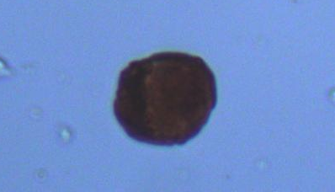 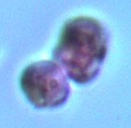

From observation, the prominence of the staining done for samples one through three is much more prevalent than the samples that had undergone two to three wash cycles.

**Figure 10. Slides of samples one through nine as well as slides for the detergent, soil sample and clean jeans.**

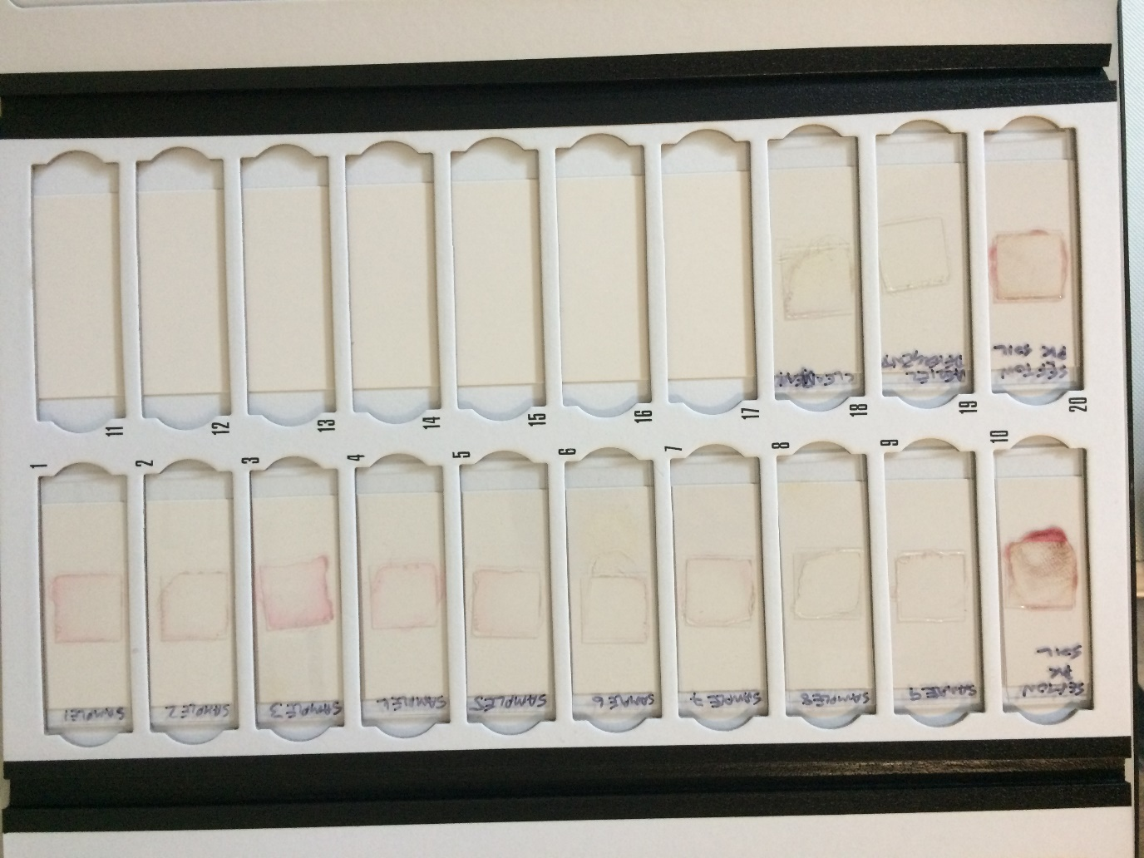

1. **Discussions:**

According to the results, traces of pollen could be found from all of the samples, even those which had undergone two to three wash cycles. Samples one through three showed the highest amounts of pollen present with a total of seventy pollen grains being counted in nine transverses. From there, the amounts of pollen found on the jean material began to decrease with the increasing wash cycles. Seven pollen grains in total were counted after nine transverses for samples four through six and six pollen grains for samples seven through nine. This shows that there is a correlation between the number of wash cycles and the amount of pollen still present on the fabric.

Regardless, the presence of pollen after not just one, but three wash cycles, could be due to a number of factors such as the type of detergent and wash cycle used, the material of fabric in which the soil and pollen adhered to, as well as the type of soil and pollen contained within the collected sample from Sefton Park. For instance, pollen grains can differ greatly from one another in terms of their sculpturing and ornamentation (Webb et al., 2018). Smooth pollen grains, which are typically associated with wind-pollinated species, maybe less likely to adhere to clothing and more susceptible to removal, whereas pollen grains with a more sculptured physicality, may be likelier to adhere to fabrics and less susceptible to removal. These type of pollen grains are typically associated with plant species that rely on animal or insect vectors (Webb et al., 2018).

In regards to whether or not the type of fabric material has a direct effect on pollen adhesion, a study done by Webb et al., 2018 which sought to explore the amount of pollen retention using different characteristics of clothing, found that there were notable differences among the different types of fabrics used. In fact, there was a significant relation to pollen retention and fabric type. Light fleece articles of clothing retained far less pollen than cotton and denim clothing, which were approximately equal in pollen retention. However, when looking at heavy wear, fleece and cotton were about the same whereas denim was substantially higher for the amount of pollen retained. Hence, during the process of washing the clothing, it is possible that it could have been one or a combination of these factors as to why trace evidence of pollen could still be found on the fabric material that was used in this research.

Forensically, this information could be of use to law enforcement when investigating a potential suspect who may have been involved in a particular crime. In New Zealand, there was a forensic case which involved two burglars who had broken into a woman's residence, and when fleeing the scene, one of them brushed against a flowering *Hypericum* bush growing outside of the back door (Mildenhall, 2006). A day after the event had occurred, a forensic examination of the suspect’s clothing took place and it was determined that *Hypericum* pollen was found on his track pants, denim jacket, and polo shirt. This pollen was identical in development, size and shape to the one growing outside of the victim’s residence. Now, if a similar incident occurred where the suspect washed their clothes that night, it would be important for investigators to realize from this research that it would still be possible to recover trace evidence of pollen from the clothing.

Furthermore, it raises the question of scene contamination particularly with archaeological sites where ongoing excavations are taking place. Archaeologists use the pollen found on artifacts and floor soils as cultural clues to better understand a civilizations use of plants, trading history, burial practices, etc. (Bryant, 2012). Pollen and spore evidence can remain intact at a site for hundreds of thousands, even millions of years due to their high resistance to decay and destruction. If collected and stored properly, they can be used for archaeological interpretation decades later after recovery. Therefore, it would be beneficial to know whether it is possible that archaeologists are carrying and transferring pollen from one site to another even though they are wearing washed articles of clothing.

1. **Further Recommendations:**

This research has shown that jeans that have been subjected to soil/pollen transfer and washed multiple times using a standard wash cycle, still contain pollen grains within the fabric material. Therefore, future studies should be conducted which seek to determine whether different wash cycles combined with different types of detergent make a difference in the retention rate of organic matter. Furthermore, in light of the results of this research, a study should be done on the transfer of pollen on jeans that have been washed to see how likely it is for contamination of archaeological sites.

1. **Conclusions:**

The results of this research shows that even after washing ones jeans multiple times using a standard wash cycle and detergent, trace evidence of pollen can still be found within denim fabric material. Further research would need to be conducted in order to test for the amount of pollen retained using different wash cycles, fabric material, and other types of pollen, but as is, this research could have numerous implications for the forensic field. In addition, it is a factor to consider when dealing with the contamination of archaeological sites and the transfer of pollen from one area to another.

**References:**

Bryant, V. (2012). "Catching Bad Guys (and Gals) Using Pollen from Archaeology to CSI.(Report)." *General Anthropology* 19: p. 1.

Bryant, V. and Jones, G. (2006). "Forensic Palynology: Current Status of a Rarely Used Technique in the United States of America." *Forensic Science International* 163.3: pp. 97-183.

Fitzpatrick, R.W. (2013). "Soils." *Encyclopedia of Forensic Sciences*. pp. 12-206.

Hunt, C. (1985). Recent Advances in Pollen Extraction Techniques: A Brief Review. *Palaeobiological Investigations.* Bar International Series 266.

Mildenhall, D., Wiltshire, P., and Bryant, V. (2006). "Forensic Palynology: Why Do It and How It Works." *Forensic Science International* 163.3: pp. 72-163.

Mildenhall, D. (2006). "Hypericum Pollen Determines the Presence of Burglars at the Scene of a Crime: An Example of Forensic Palynology." *Forensic Science International* 163.3: pp. 35-231.

Scott, K., Morgan, R., Jones, V., and Cameron, N. (2014). "The Transferability of Diatoms to Clothing and the Methods Appropriate for Their Collection and Analysis in Forensic Geoscience." *Forensic Science International* 241: pp. 37-127.

Warny, S. (2013). "Museums' Role: Pollen and Forensic Science." *Science* 339.6124: p. 1149.

Webb, J., Brown, H., Toms, H., and Goodenough, A. (2018). "Differential Retention of Pollen Grains on Clothing and the Effectiveness of Laboratory Retrieval Methods in Forensic Settings." *Forensic Science International* 288: pp. 36-45.

Young, J., Weyrich, L., Breen, J., Macdonald, L., and Cooper, A. (2015). "Predicting the Origin of Soil Evidence: High Throughput Eukaryote Sequencing and MIR Spectroscopy Applied to a Crime Scene Scenario." *Forensic Science International* 251: pp. 22-31.